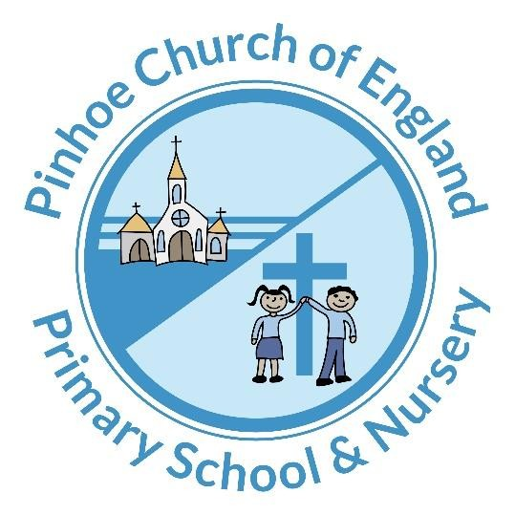

Pinhoe C of E School & Nursery

School Uniform Policy- DRAFT

Approved by: | Governors | Date 23.03.26
Last reviewed: | March 2026
Next review date: | March 2027

Contents
- Aims .................................................................................................................................................................
- Our school’s legal duties under the Equality Act 2010 ....................................................................................
- Limiting the cost of school uniform ..................................................................................................................
- Expectations for school uniform ......................................................................................................................
- Expectations for our school community ...........................................................................................................
- Monitoring arrangements .................................................................................................................................

Aims

Pinhoe C of E School’s uniform policy aims to:
Set out our approach to requiring a uniform that is of reasonable cost and offers the best value for money for parents and carers
Explain how we will avoid discrimination in line with our legal duties under the Equality Act 2010 Clarify our expectations for school uniform

Our school’s legal duties under the Equality Act 2010

The Equality Act 2010 prohibits discrimination against an individual based on the protected characteristics, which include sex, race, religion or belief, and gender reassignment.
To avoid discrimination, our school will:
Avoid listing uniform items based on sex, to give all pupils the opportunity to wear the uniform they feel most comfortable in or that most reflects their self-identified gender
Make sure that our uniform costs the same for all pupils
Allow all pupils to have long hair (though we reserve the right to ask for this to be tied back)
Allow all pupils to style their hair in the way that is appropriate for school yet makes them feel most comfortable
Allow pupils to request changes to swimwear for religious reasons
Allow pupils to wear headscarves and other religious or cultural symbols
Allow for adaptations to our policy on the grounds of equality by asking pupils or their parents to get in touch with the Head of School who can answer questions about the policy and respond to any requests

Limiting the cost of school uniform

We acknowledge and have taken full account of recent DfE legislation regarding inclusivity and costs of school uniform and have taken on board the views and opinions of parents in our school community in order to revise this uniform policy:
https://www.headteacher-update.com/resources-article/resource-helps-schools-to-navigate-new-uniform-lawschildrens-society-wrong-blazer-poverty-families-1/245406/
Our school has a duty to make sure that the uniform we require is affordable, in line with statutory guidance from the Department for Education on the cost of school uniform.
We understand that items with distinctive characteristics (such as branded items, or items that have to have a school logo or a unique fabric/colour/design) cannot be purchased from a wide range of retailers and that requiring many such items limits parents’ ability to ‘shop around’ for a low price.

We will make sure our uniform policy
Is available to purchase at a reasonable cost
Provides the best value for money for our parents/carers.

We will do this by

Carefully considering whether any items with distinctive characteristics are necessary
Limiting any items with distinctive characteristics, for example, as from September 2022, we will only require the school jumper or cardigan, to feature the school logo. No other items are required to feature a school logo, meaning parents are free to purchase uniform in a wider range of places, at reduced costs.
Allowing cheaper alternatives to school-branded items, for all other uniform
Avoiding specific requirements for items pupils could wear on non-school days, such as book bags, which are optional
Ensuring that all uniform requirements for different year groups is the same
Making sure that second-hand uniform items are available to parents, should they require them
Avoiding frequent changes to uniform specification
Consulting with parents and pupils on any proposed significant changes to the uniform policy and consulting parent opinions prior to doing so.

Expectations for Pinhoe C of E School & Nursery’s school uniform

Which items are required to be branded?
Only the blue school jumper or blue cardigan will require the school logo.

Nursery Uniform
Please note our Nursery children will also be required to wear a blue school jumper or cardigan bearing our school logo. Other items of clothes for our nursery children are optional.
Please can children wear lightweight and practical footwear.

Which items of school uniform do not have to be branded (remain optional)?

(Applicable for Reception, Years 1,2,3,4,5 & 6 children)
Logos on any other piece of school uniform is completely optional. ie: White polo shirt, Red PE sweatshirt, black jogging bottoms, black shorts, blue PE T-shirt, Fleece.
This means that parents & carers can choose where to buy these items and are free to purchase in a wider range of shops or online at a reduced cost.

Expectations for PE uniform (Applicable for Reception, Years 1,2,3,4,5 & 6 children)
PE days will be fixed and shared with parents in advance. This allows our children to wear their PE kit all day on PE days, instead of having to change.
We will allow non branded/ non logo PE items in the following colours:
- Red PE sweatshirt
- Blue PE T-shirt
- Black jogging bottoms
- Black shorts
- Trainers, no plimsoles

Please note Nursery children do not require a PE kit uniform.

 | ALLOWED  |  | NOT ALLOWED 
JUMPER | 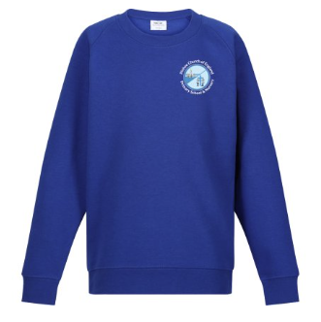  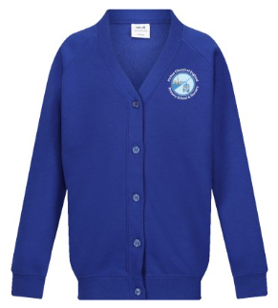 |  | 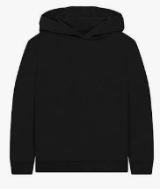
POLO SHIRT | 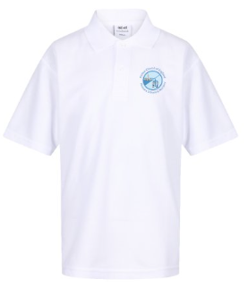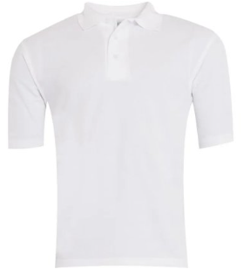
SHORTS | 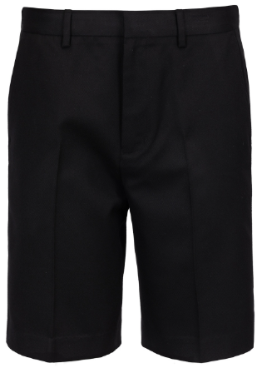 |  | 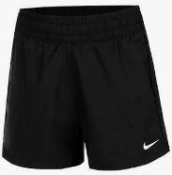
SKIRTS | 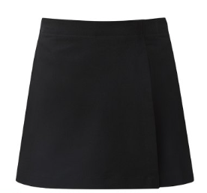 |  | 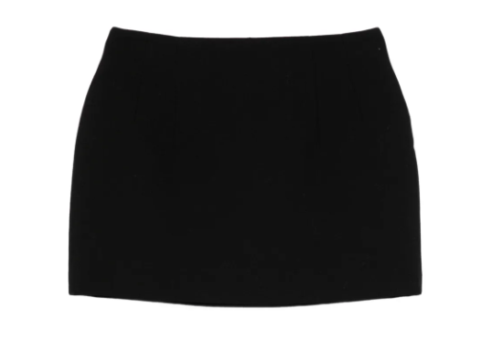
DRESSES | 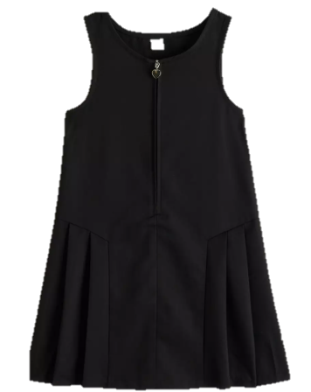  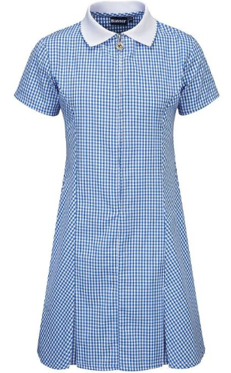
SHOES | 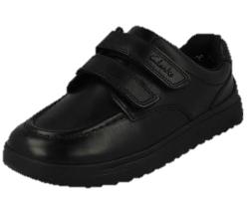  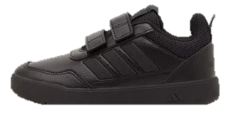  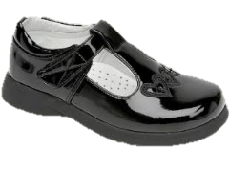  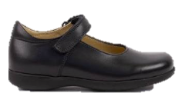 |  | 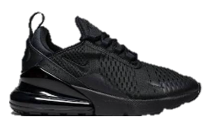  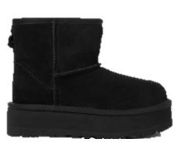  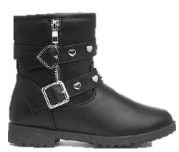
PE SHORTS | 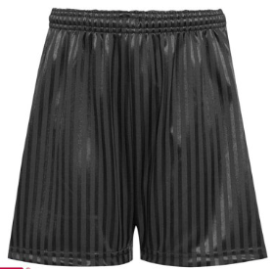  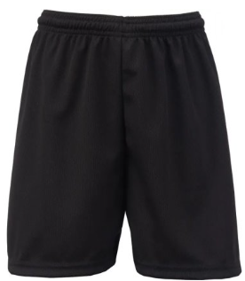 |  | 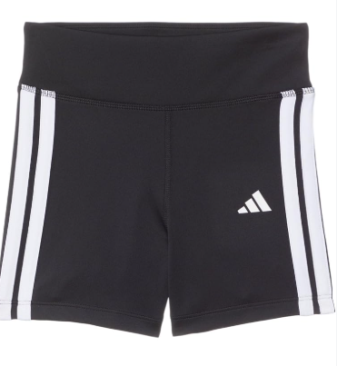  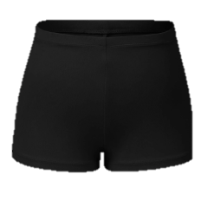
PE JOGGER | 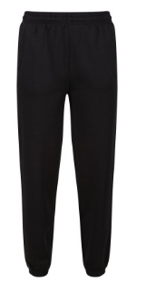  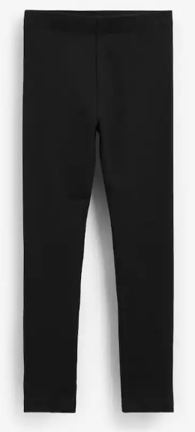 |  | 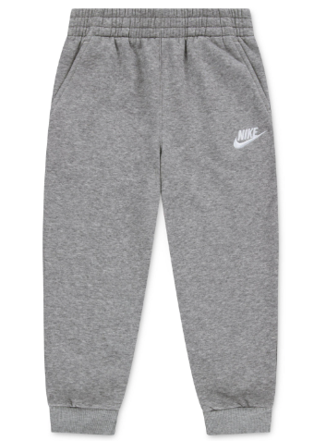
PE TOP | 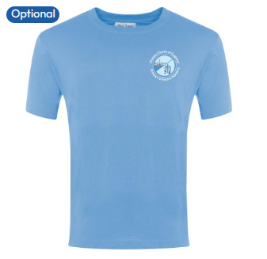  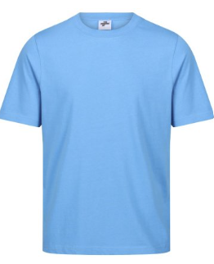
PE JUMPER | 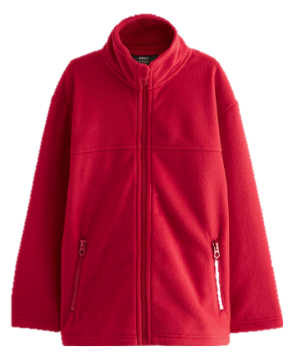  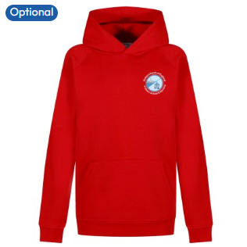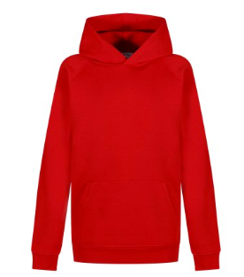 |  | 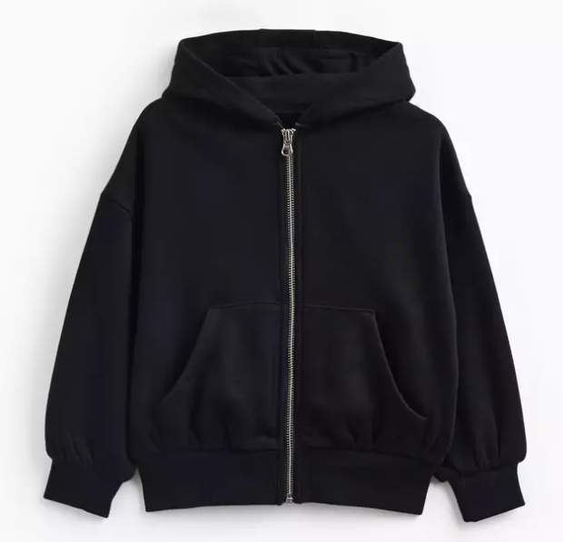
PE TRAINERS |  | 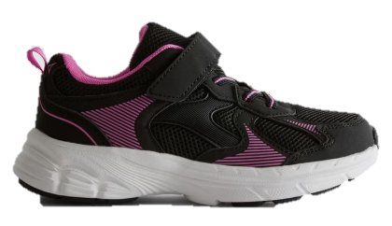  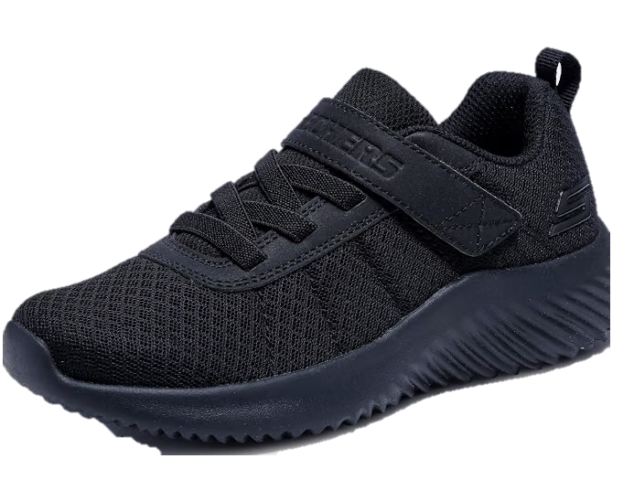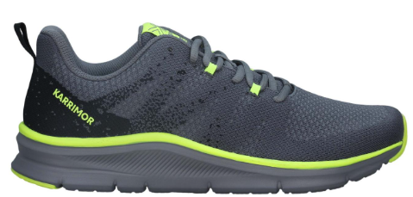 | 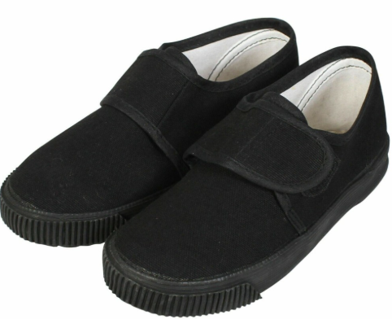  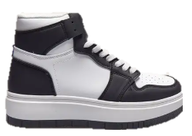  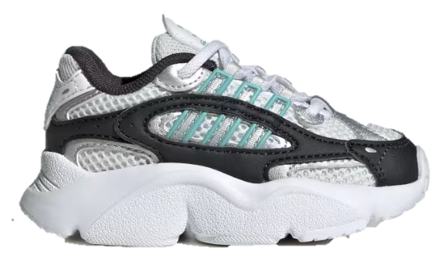

Jewellery, Watches & Hairstyles
Please note that children are not permitted to wear make-up in school, including nail polish. If your child has long hair this should be tied up or worn with a hair band. Watches (but not Smart watches) and stud earrings are the only items of jewellery which can be worn and these need to be removed for PE lessons. Elaborate hairstyles such as tracks or excessively short cuts are not permitted nor are styles which involve unnatural hair colouring.
We allow pupils to wear headscarves and other religious or cultural symbols

Shoes
We ask that children wear only black shoes (not boots) or black trainers that look like shoes which are available in school uniform sections at large supermarkets/ shops.

Coats
We do not set any rules for types of coats. Families are asked to send their children in to school wearing warm, waterproof coats.

Where to purchase School Uniform
Pinhoe C of E School’s main school uniform supplier is:
Thomas Moore
102 / 104 Fore Street
Exeter
Ex4 3JB

Telephone number: 01392 255711
https://www.thomasmooretoymaster.com/

Pre-loved uniform

Pre-loved uniform is available via our school reception and PTFA team. Please contact us at school or come in to speak with an office member of staff and we can help you with obtaining second hand uniform.

Expectations for our school community

5.1 Pupils
Pupils are expected to wear the correct uniform at all times (other than specified non-school uniform days) while:
On the school premises
Travelling to and from school
At out-of-school events or on trips that are organised by the school, or where they are representing the school (if required)
Parents can contact pinhoe-office@cedartreefederation.org if they want to request an amendment to the uniform policy in relation to their protected characteristics.

Parents and carers
Parents and carers are expected to make sure their child has the correct uniform and PE kit, and that every item is:
Clean
Clearly labelled with the child’s name
Parents are also expected to contact the school office if they want to request an amendment to the uniform policy in relation to:
Their child’s protected characteristics
The cost of the uniform

Parents should lodge any complaints or objections relating to the school uniform in a timely and reasonable manner.

Disputes about the cost of the school uniform will be:
Resolved locally
Dealt with in accordance with our school’s complaints policy
The school will work closely with parents to arrive at a mutually acceptable outcome.

Staff

Staff will closely monitor pupils to make sure they are in correct uniform. They will give any pupils and families breaching the uniform policy the opportunity to comply but will follow up with the senior leaders if the situation doesn’t improve.
Ongoing breaches of our uniform policy will be handled by senior leaders.
In cases where it is suspected that financial hardship has resulted in a pupil/ pupils not complying with this uniform policy, staff will take a mindful and considerate approach to resolving the situation.

  - Governors

The governing board will review this policy and make sure that it:
Is appropriate for our school’s context
Is implemented fairly across the school
Takes into account the views of parents and pupils
Offers a uniform that is appropriate, practical and safe for all pupils
Governors and senior leaders will also make sure that the school’s uniform supplier arrangements give the highest priority to cost and value for money, for example by avoiding single supplier contracts and by re-tendering contracts at least every 5 years.

Monitoring arrangements

This policy will be reviewed annually by the Head Teacher. At every review, it will be approved by the Governing Body.

